Inaccurate Accounting can ruin your Business, stay FOCUSED!

To succeed in your business, you need to know your financial numbers and streamline them frequently. If you don’t, how can you know how much money is coming in and going out of your business?

When you run a business, there should be no room for unorganized, inaccurate accounting.

If you are falling behind to log transactions, you won’t have a clear idea of how much money your business has. For instance, if you buy a number of supplies but don’t enter the transactions into your accounting records right that moment, your records will show that you have more money than you actually do. As a result, you might spend more, which will cause a negative cash flow for your business.

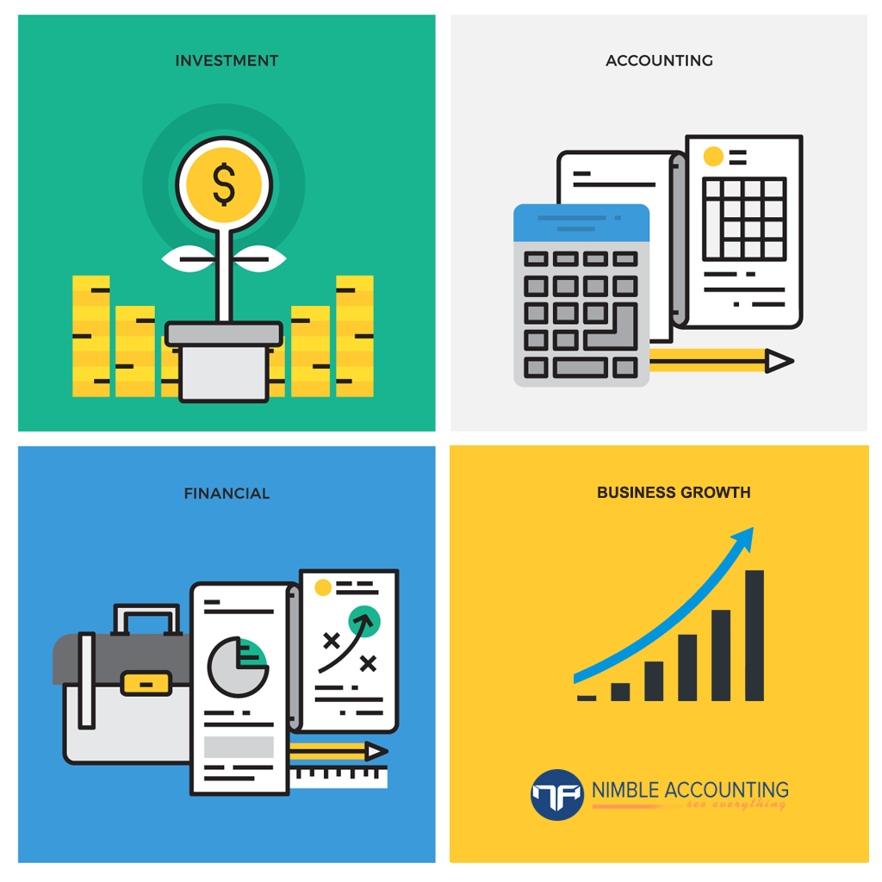

For that reason, accurate recording of your transactions is important. Minor errors like mixing up numbers or recording items in the wrong fashion can devastate your business. To avoid these errors, you need to regularly reconcile your books, conduct internal audits, and hire an accounting software to keep your business records streamlined.

If you’re a looking to prosper in this progressively economy, then you must have a [well-designed accounting software](http://blog.nimbleaccounting.com/automated-accounting-software-the-best-fit-for-you/). Nimble Accounting software will not only save you from the stress of controlling finances and ensuring cash flow but also will provide an overall business health at a glance so as to ensure your company to be seen in a whole new light.

It is easy to GET STARTED with Nimble, try it for FREE!

More info @staffing.nimbleaccounting.com

T: 1-866-964-6253

E: [sales@nimbleaccounting.com](mailto:sales@nimbleaccounting.com)